POINTS TO BE FOLLOWED WHILE MAKING THE REPORT

FONT STYLE TO BE USED: TIMES NEW ROMAN
FONT SIZE FOR THE BODY:12 PT
FONT SIZE FOR THE HEADING:16 PT (Titles and headings, sub headings may be in bold.)
FONT SIZE FOR THE HEADING:14 PT
ALIGNMENT: JUSTIFY
SPACING: 1.5-line spacing is recommended.

INSTALL GRAMMARLY, SO THAT SPELLING AND GRAMMATICAL MISTAKES CAN BE AVOIDED.

ABSTRACT — An Abstract is usually 100 to 200 words and should include the following:
• why the report has been written (i.e. what question or problem is it addressing?)
• how the study was undertaken
• what the main findings were
• what the significance of the findings is.

INTRODUCTION — The Introduction has three main components.
1. The Background which describes events leading up to the existing situation, what projects have been done previously, and why the project or study is necessary.
2. The Purpose which defines what the project or study is to achieve, who authorized it and the specific terms of reference.
3. The Scope which outlines any limitations imposed on the project such as cost, time etc.

LITERATURE SURVEY AND OTHER CHAPTERS WILL VARY FROM PROJECT TO PROJECT, SO FOLLOW THE GUIDE INSTRUCTIONS STRICTLY.

PAGES BEFORE INTRODUCTION STARTS SHOULD BE NUMBERED IN ROMAN NUMBERS (I, II, III……). FROM INTRODUCTION NUMBERING OF THE PAGES CAN BE DONE AS 1,2,3…..

SUGGESTION: REPORT SHOULD CONTAIN A MINIMUM OF 40 PAGES, MAXIMUM UPTO 60
ADD LIST OF CO’s, PO’S, PSO’s AND PO ATTAINEMENT TABLE AFTER CONCLUSION

CO-PO-PSO Mapping
Course Outcomes (CO’s):
- Demonstrate the ability to present and explain the complete project work effectively through professional demonstrations and presentations.
- Develop and implement a fully functional system/application that meets specified requirements and operates reliably.
- Exhibit high implementation quality and technical depth by applying appropriate algorithms, tools, and engineering practices.
- Perform systematic testing and validation to ensure correctness, reliability, and performance of the developed system.
- Analyze project outcomes, draw meaningful conclusions, and engage in critical discussion for further improvement and future scope.
- Prepare a comprehensive project draft report following standard technical documentation practices.
Program Outcomes (POs)
- Engineering knowledge: Apply the knowledge of mathematics, science, engineering fundamentals and an engineering specialization to the solution of complex engineering problems.
- Problem analysis: Identify, formulate, review research literature, and analyze complex engineering problems reaching substantiated conclusions using first principles of mathematics, natural sciences, and engineering sciences.
- Design/development of solutions: Design solutions for complex engineering problems and design system components or processes that meet the specified needs with appropriate consideration for the public health and safety, and the cultural, societal, and environmental considerations.
- Conduct investigations of complex problems: Use research-based knowledge and research methods including design of experiments, analysis and interpretation of data, and synthesis of the information to provide valid conclusions.
- Modern tool usage: Create, select, and apply appropriate techniques, resources, and modern engineering and IT tools including prediction and modeling to complex engineering activities with an understanding of the limitations.
- The engineer and society: Apply reasoning informed by the contextual knowledge to assess societal, health, safety, legal and cultural issues and the consequent responsibilities relevant to the professional engineering practice.
- Environment and sustainability: Understand the impact of the professional engineering solutions in societal and environmental contexts, and demonstrate the knowledge of, and need for sustainable development.
- Ethics: Apply ethical principles and commit to professional ethics and responsibilities and norms of the engineering practice.
- Individual and team work: Function effectively as an individual, and as a member or leader in diverse teams, and in multidisciplinary settings.
- Communication: Communicate effectively on complex engineering activities with the engineering community and with society at large, such as, being able to comprehend and write effective reports and design documentation, make effective presentations, and give and receive clear instructions.
- Project management and finance: Demonstrate knowledge and understanding of the engineering and management principles and apply these to one’s own work, as a member and leader in a team, to manage projects and in multidisciplinary environments.
- PO12: Life-long learning: Recognize the need for, and have the preparation and ability to engage in independent and life-long learning in the broadest context of technological change.
Program Specific Outcome (PSO’s):

PSO 1 | Apply algorithmic thinking and utilize programming languages such as C, Python and Java to develop and maintain efficient and robust computing systems.
PSO 2 | Design and develop computer-based applications of varying complexities using emerging topics of Computer Science and Engineering such as cloud computing, artificial intelligence, data processing etc.
PSO 3 | Possess the subject knowledge and scientific temper necessary to pursue successful careers in Computer Science and Engineering with ethical responsibility towards societal needs.

CO–PO–PSO Articulation Matrix (Capstone Project – Final (PROJ3999))
Correlation Scale: 3 – High | 2 – Moderate | 1 – Low

COs | PO1 | PO2 | PO3 | PO4 | PO5 | PO6 | PO7 | PO8 | PO9 | PO10 | PO11 | PO12 | PSO1 | PSO2 | PSO3
CO1 | 3 | 2 | 2 | 2 | 2 | 1 | 1 | 2 | 2 | 3 | 2 | 1 | 2 | 2 | 2
CO2 | 3 | 3 | 3 | 2 | 3 | 1 | 2 | 2 | 2 | 2 | 2 | 1 | 3 | 3 | 2
CO3 | 3 | 3 | 3 | 3 | 3 | 1 | 2 | 2 | 2 | 2 | 2 | 1 | 3 | 3 | 2
CO4 | 3 | 3 | 2 | 3 | 2 | 1 | 1 | 2 | 2 | 2 | 2 | 1 | 3 | 2 | 2
CO5 | 2 | 2 | 2 | 2 | 1 | 2 | 2 | 2 | 2 | 3 | 2 | 2 | 2 | 1 | 3
CO6 | 2 | 2 | 2 | 2 | 2 | 1 | 1 | 3 | 2 | 3 | 3 | 2 | 2 | 2 | 3

CO–PO–PSO Articulation Table (Project Title: )

Correlation Scale: 3 – High | 2 – Moderate | 1 – Low
COs | PO1 | PO2 | PO3 | PO4 | PO5 | PO6 | PO7 | PO8 | PO9 | PO10 | PO11 | PO12 | PSO1 | PSO2 | PSO3
CO1
CO2
CO3
CO4
CO5
CO6

CO–PO–PSO Detailed Justification Tables (Project Title: )

CO1: Demonstrate the ability to present and explain the complete project work effectively through professional demonstrations and presentations.
PO / PSO | Level | Justification
PO1
PO2
PO3
PO4
PO5
PO6
PO7
PO8
PO9
PO10
PO11
PO12
PSO1
PSO2
PSO3

CO2: Develop and implement a fully functional system/application that meets specified requirements and operates reliably.
PO / PSO | Level | Justification
PO1
PO2
PO3
PO4
PO5
PO6
PO7
PO8
PO9
PO10
PO11
PO12
PSO1
PSO2
PSO3

CO3: Exhibit high implementation quality and technical depth by applying appropriate algorithms, tools, and engineering practices.
PO / PSO | Level | Justification
PO1
PO2
PO3
PO4
PO5
PO6
PO7
PO8
PO9
PO10
PO11
PO12
PSO1
PSO2
PSO3

CO4: Perform systematic testing and validation Perform systematic testing and validation to ensure correctness, reliability, and performance of the developed system.
PO / PSO | Level | Justification
PO1
PO2
PO3
PO4
PO5
PO6
PO7
PO8
PO9
PO10
PO11
PO12
PSO1
PSO2
PSO3

CO5: Analyze project outcomes, draw meaningful conclusions, and engage in critical discussion for further improvement and future scope.
PO / PSO | Level | Justification
PO1
PO2
PO3
PO4
PO5
PO6
PO7
PO8
PO9
PO10
PO11
PO12
PSO1
PSO2
PSO3

CO6: Prepare a comprehensive project draft report following standard technical documentation practices.
PO / PSO | Level | Justification
PO1
PO2
PO3
PO4
PO5
PO6
PO7
PO8
PO9
PO10
PO11
PO12
PSO1
PSO2
PSO3

Sustainable Development Goals (SDGs)
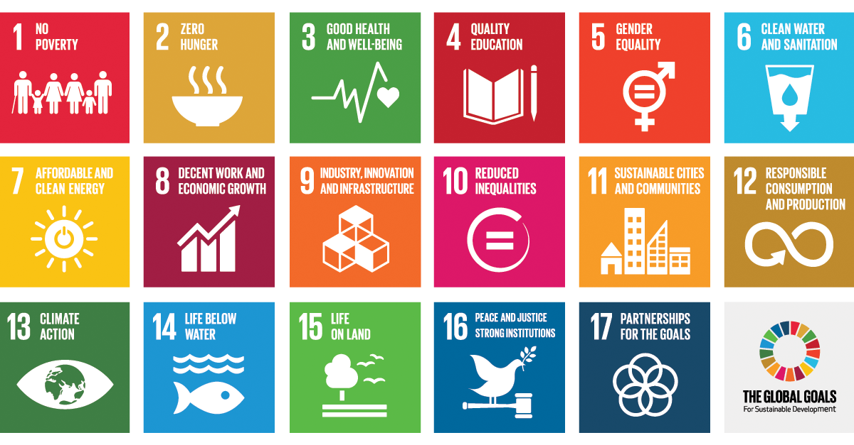

CO–SDG Mapping with Justification (Project Title: )

Note: List the SDG’s Number & Title for which your project falls under the SDGs.

SDG No. | SDG Title

COs | SDG No(s) | SDG Title(s)
CO1
CO2
CO3
CO4
CO5
CO6

CO1: Demonstrate the ability to present and explain the complete project work effectively through professional demonstrations and presentations.
Mapped SDGs:
Justification:

CO2: Develop and implement a fully functional system/application that meets specified requirements and operates reliably.
Mapped SDGs:
Justification:

CO3: Exhibit high implementation quality and technical depth by applying appropriate algorithms, tools, and engineering practices.
Mapped SDGs:
Justification:

CO4: Perform systematic testing and validation to ensure correctness, reliability, and performance of the developed system
Mapped SDGs:
Justification:
- .
- .

CO5: Analyze project outcomes, draw meaningful conclusions, and engage in critical discussion for further improvement and future scope
Mapped SDGs:
Justification:

CO6: Prepare a comprehensive project draft report following standard technical documentation practices
Mapped SDGs:
Justification:

REFERENCES

Journals and Conferences

- Hamoud, A., Hoenig, A. and Roy, K., 2022. Sentence subjectivity analysis of a political and ideological debate dataset using LSTM and BiLSTM with attention and GRU models. Journal of King Saud University-Computer and Information Sciences, 34(10), pp.7974-7987, 2022.
- Bouaziz, F., Oulhadj, H., Boutana, D. and Siarry, P., 2019. Automatic ECG arrhythmias classification scheme based on the conjoint use of the multi‐layer perceptron neural network and a new improved metaheuristic approach. IET Signal Processing, 13(8), pp.726-735.
- A. Varshney, R. Kolhe, S. Gatne and V. V. Ingale, "Arrhythmia Classification of ECG Signals Using Undecimated Discrete Wavelet Transform," 2022 IEEE 7th International conference for Convergence in Technology (I2CT), Mumbai, India, 2022, pp. 1-5.
- Babu, D.V., Karthikeyan, C. and Kumar, A., 2020, December. Performance analysis of cost and accuracy for whale swarm and RMSprop optimizer. In IOP Conference Series: Materials Science and Engineering (Vol. 993, No. 1, p. 012080). IOP Publishing.
Websites
- How to; 5 Top methods & applications to reduce Twitterspam, http://blog.thoughtpick.com/2009/07/how-to-5-topmethods-application-to-reduce-twitter-spam.html

IEEE STYLE OF REFERENCING TO BE FOLLOWED FOR BOTH JOURNAL/CONFERENCE PAPERS, TEXT BOOKS, AND ALSO FOR ANY LINK USED.

